6-month Biological Field Crew Positions at Midway Atoll National Wildlife Refuge 2022
Description:
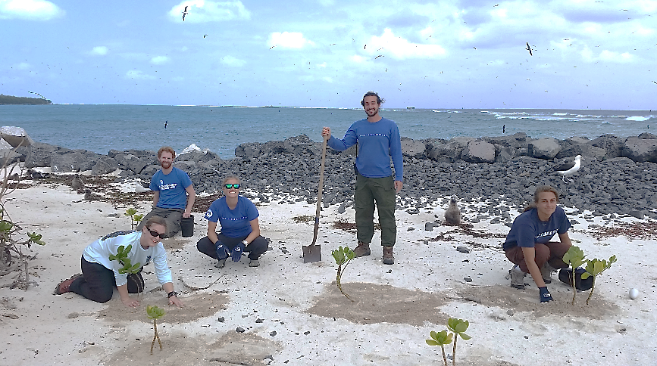The U.S. Fish and Wildlife Service (Service) is seeking volunteers for the biological program at Midway Atoll National Wildlife Refuge from September 6, 2022 to late March 2023. The biological program focuses on controlling and removing non-native species and maintaining, conserving, and restoring quality habitat to support indigenous plants, seabirds, waterbirds, monk seals, and sea turtles. In addition to being a National Wildlife Refuge, Midway Atoll is also designated as the Battle of Midway National Memorial and is part of Papahānaumokuākea Marine National Monument. Midway Atoll is a remote field site located over 1,300 miles from the main Hawaiian Islands and is inhabited by a small community of ~50 residents comprising FWS staff, volunteers, and contractors.
Duties and Responsibilities:
Volunteers work 40 hours/week (typically Monday-Friday) with additional nights, early mornings, and weekend work as needed. Volunteer work includes invasive plant removal using manual and chemical applications of herbicides, native plant propagation, seed collection and processing, seabird and Laysan duck monitoring, marine debris removal, data entry and proofing, equipment maintenance, and other tasks addressing current refuge needs.
Special Considerations:
Midway Atoll is an extremely remote site and receives supplies occasionally by plane or ship. Due to weight restrictions on flights and irregularity of ship schedules, volunteers must be prepared to have all necessary amenities (i.e. toiletries and medications) with them upon arrival. Communication is limited to landline phones (no cellular service) and limited internet access. Transportation on island will primarily be by foot or bicycle. Weather conditions often include strong winds, tropical storms, and hot sun. Safety is of primary concern. Although a physician’s assistant is on staff to provide some medical care, volunteers should be aware that evacuation for emergencies or major medical issues typically takes at least 24 hours and can be very expensive; so volunteers are strongly encouraged to carry medical-evacuation insurance. Any medical concerns (e.g., adverse reactions to jellyfish or bee stings, food allergies, asthma) should be discussed (with staff and/or a medical provider) prior to arrival to Midway to determine if being on a remote, isolated island is in the best interest of the volunteer and the Service. Due to current public health concerns, volunteers could be exposed to COVID-19 during your volunteer duties and must follow protective measures implemented by the Service and the CDC. We currently require all incoming personnel to be fully vaccinated against COVID and to wear face masks and practice social distancing for their first 10 days on Midway.
Selected applicants will be sent a packet of required forms and additional information on the island, duties, and suggested items to bring. Required forms must be submitted before the volunteer arrives for duty in Honolulu. Volunteers are required to follow instructions for obtaining a government PIV card before arriving to Honolulu, which can take up to one month. A current physical, tetanus shot, TB test, and proof of COVID vaccination are also required. The Service will provide transportation between Honolulu and Midway Atoll, as well as housing and meals while on Midway Atoll.

Qualifications:
- Must be willing and able to work 40+ hours per week.
- Must be in excellent physical and mental condition; able to walk 10 miles a day over variable terrain, lift and carry 25 lbs., ride a bicycle, swim, and be able to perform repetitive stooping and bending motions.
- Must be able to perform all duties in inclement weather, including high heat and humidity during the summer, strong winds, and heavy rain.
- Must be able to pass a swim test (100 m swim, 100 m snorkel, and 2 minutes treading water).
- Must be comfortable with the use of pesticides and follow recommended safety protocols.
- Must have a valid driver’s license and current passport that does not expire for at least one year.
Desired Skills/Experience:
- Remote field experience with a focus on:
  - invasive species control
  - plant identification and plant propagation
  - avian identification, handling, and reproductive monitoring
- Ideal candidates will possess:
  - strong interpersonal skills
  - able to work well independently as well as closely in a small group
  - easy-going with a good sense of humor
  - flexibility for adapting to changing conditions and schedules
  - experience working in the Hawaiian archipelago or other island systems
  - boating, kayaking, and snorkel experience
To Apply:
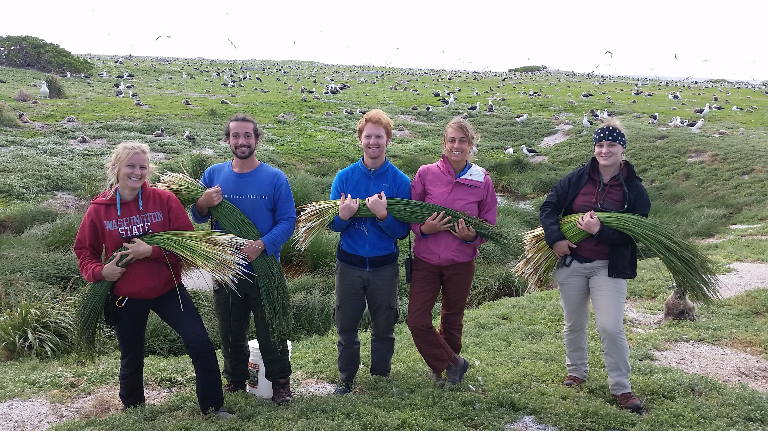Please email a single PDF file in the following format: YourLastName_Winter2022.pdf that includes your cover letter, resume/CV, relevant certifications, and at least three references. You may send your application materials with the subject line “Midway Atoll Volunteer Application” to Laura Brazier at laura_brazier@fws.gov. Please direct any questions to Laura as well. Applications are due by May 20, 2022.

