6-month Biological Field Crew Positions at Midway Atoll National Wildlife Refuge

Description:

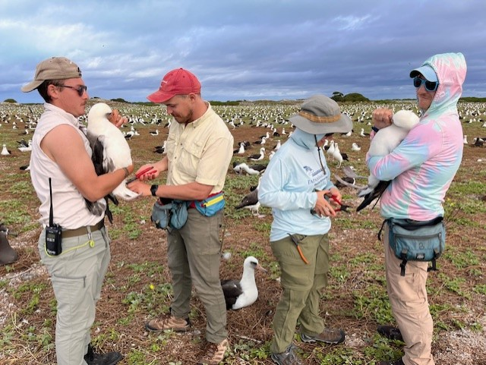The U.S. Fish and Wildlife Service is seeking crew members for the biological program at Midway Atoll National Wildlife Refuge from approximately March 25, 2025 to September 2, 2025. The biological program focuses on controlling and removing non-native species and maintaining, conserving, and restoring quality habitat to support indigenous plants, seabirds, waterbirds, monk seals, and sea turtles. In addition to being a National Wildlife Refuge, Midway Atoll is also designated as the Battle of Midway National Memorial and is part of Papahānaumokuākea Marine National Monument. Midway Atoll is a remote field site located over 1,300 miles from the main Hawaiian Islands and is inhabited by a small community of ~50 residents comprising FWS staff, volunteers, and contractors.

**Duties and Responsibilities:**

Field crew members work 40 hours/week (typically Monday-Friday) with additional nights, early mornings, and weekend work as needed. Work predominantly includes invasive plant removal using manual and chemical applications of herbicides, Laysan and Black-footed albatross monitoring, Laysan duck monitoring, sea turtle monitoring, native plant propagation, data entry and proofing, and other tasks addressing current refuge needs. Assistance with ant monitoring and monk seal surveys as needed.

**Special Considerations:**   
Midway Atoll is an extremely remote site and receives supplies by plane every two weeks and by supply ship a few times a year. Communication is limited to landline phones (no cellular service) and limited Wifi internet access through Starlink. Transportation on island will primarily be by foot or bicycle. Weather conditions often include strong winds, tropical storms, and hot sun. Safety is of primary concern. Although a physician’s assistant is on staff to provide some medical care, applicants should be aware that evacuation for emergencies or major medical issues typically takes at least 24 hours and can be very expensive. Any medical concerns (e.g., adverse reactions to jellyfish or bee stings, food allergies, asthma) should be discussed (with staff and/or a medical provider) prior to arrival to Midway to determine if being on a remote, isolated island is in the best interest of the crew member.

Selected applicants will be sent a packet of required forms and additional information on the island, travel requirements, duties, and suggested items to bring. Crew members are required to follow instructions for obtaining a government PIV card before arriving to Honolulu, which can take up to one month. A current tetanus shot is also required. Housing and all meals will be covered, as well as transportation costs via charter aircraft between Honolulu and Midway. In addition, a $1,000 stipend for each crew member will be gifted by the Refuge's non-profit association, Friends of Midway Atoll, upon the season’s completion.

**Qualifications:**

* Must be willing and able to work 40+ hours per week.
* Must be in excellent physical and mental condition; able to walk 10 miles a day over variable terrain, lift and carry 25 lbs., ride a bicycle, and be able to perform repetitive stooping and bending motions.
* Must be able to perform all duties in inclement weather, including high heat and humidity during the summer, strong winds, and heavy rain.
* Must be comfortable with the use of pesticides and follow recommended safety protocols.
* Must have a valid driver’s license and current passport that does not expire for at least one year.
* Must be **flexible** and adaptive to changing conditions and schedules  
    
  **Desired Skills/Experience:**
* Remote field experience with a focus on:
  + invasive species control
  + plant identification and plant propagation
  + avian identification, handling, and reproductive monitoring
  + recording detailed field data using data forms and field tablets
* Ideal candidates will possess:
  + strong interpersonal skills and self-motivating work ethic
  + ability to work well independently as well as closely in a small group
  + easy-going personality with a good sense of humor
  + experience working in the Hawaiian archipelago or other island systems
  + experience entering and proofing data using Microsoft Excel

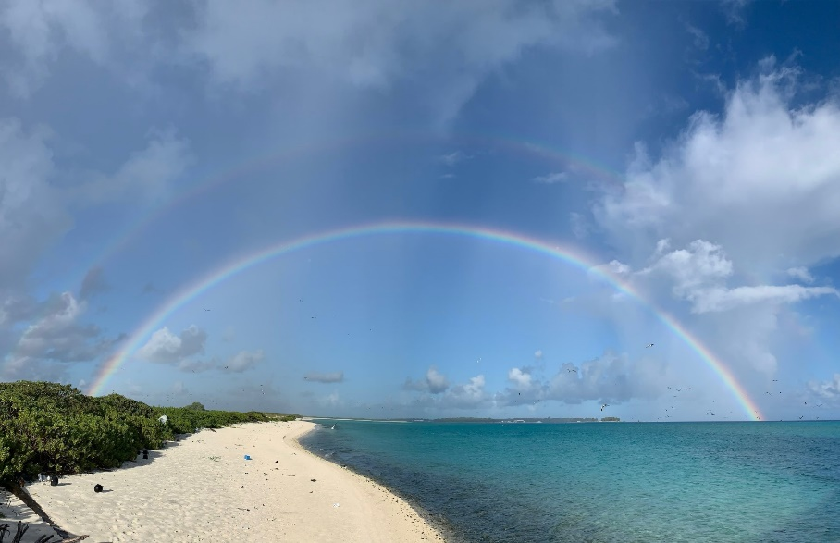**To Apply:**

Please email a single PDF file (file name: YourLastName_Spring2025.pdf) that includes your cover letter, resume/CV, relevant certifications, and contact information for at least three references. Please send your application materials with the subject line “Midway Atoll Volunteer Application” to Laura Brazier at laura_brazier@fws.gov. Please direct any questions to Laura as well. Applications are due by December 13, 2024.